Project Report

Building an AI-Powered Predictive Model of Credit Card Fraud Detection
1. Problem Statement
The increasing frequency of credit card fraud has become a major concern for financial institutions and customers worldwide. Fraudulent transactions lead to significant financial losses and reduce trust in digital payment systems.
This Project aims to develop a Machine Learning-based fraud detection system that analyzes transaction data such as transaction amount, time, location, and user demographics to identify suspicious activities. The model will classify transactions as either fraudulent or legitimate, enabling early detection and prevention of fraud.
1.1 Significance of the Project:
Credit card fraud detection is a critical challenge in the financial sector. An effective detection system can provide the following benefits:
- Minimise financial losses caused by fraudulent transactions
- Enhance customer trust in digital payment systems
- Reduce risk for banks and financial institutions
- Improve overall security and reliability of online transactions
1.2 Problem Definition:
The problem addressed in this project is a binary classification problem, where each transaction must be classified as:
Legitimate (0)
Fraudulent (1)
Using historical transaction data, Machine Learning models are trained to recognise patterns and detect anomalies that indicate fraudulent behaviour.
2. Dataset Description
- Source: Kaggle(https://www.kaggle.com/datasets/kartik2112/fraud-detection)
- Number of Records: 555,719 rows
- Number of Features: 23 columns
- Features:
- User demographics(age, gender)
- Transaction details (category, amount, merchant)
- Location data ( state, latitude, longitude, city population)
- Other (cc_num, etc)

- Target Variable: is_fraud
3. Statistical Analysis
3.1 Descriptive Statistics
The Descriptive Statistics are simple tools that help us understand and summarise data.
- The dataset contains both numerical and categorical features
- The data is highly imbalanced, with significantly fewer fraudulent transactions compared to legitimate ones
- Features such as age, transaction amount, and transaction time play an important role in identifying fraud patterns.
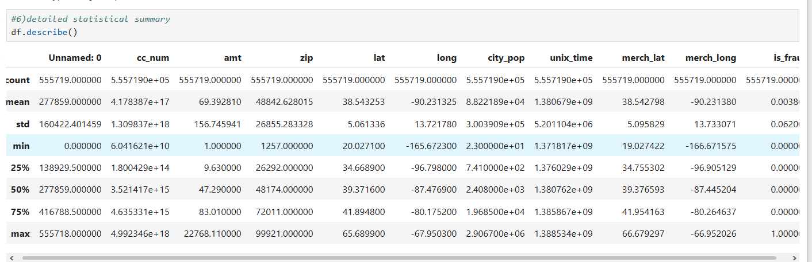
3.2 Distribution Analysis
Distribution plots were used to understand how the data is spread across different variables.
- Fraud vs Non-Fraud Distribution:
- The dataset is highly imbalanced, with very few fraud cases.
- This imbalance highlights the need for special handling techniques.

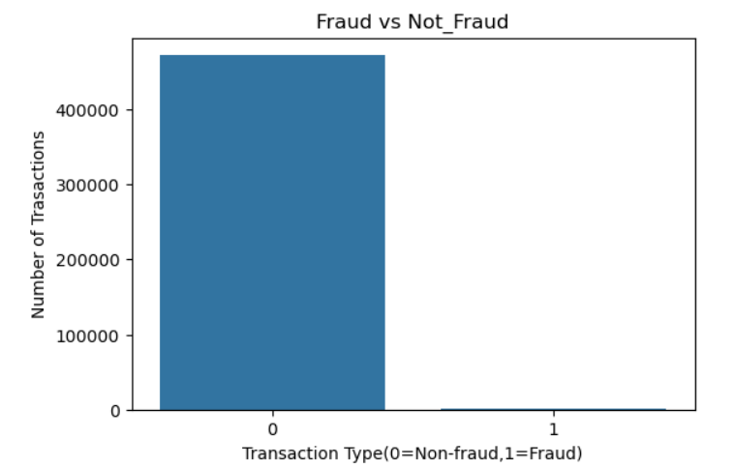
- Age Distribution
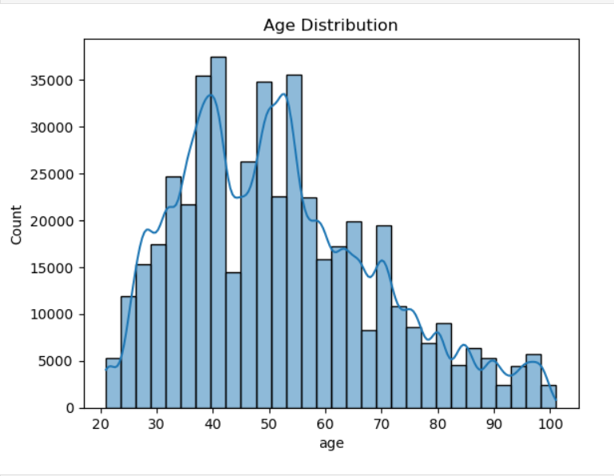
3.3 Correlation Analysis
Correlation analysis was performed to identify relationships between numerical features.
- Correlation heatmap helps in identifying important features for model training
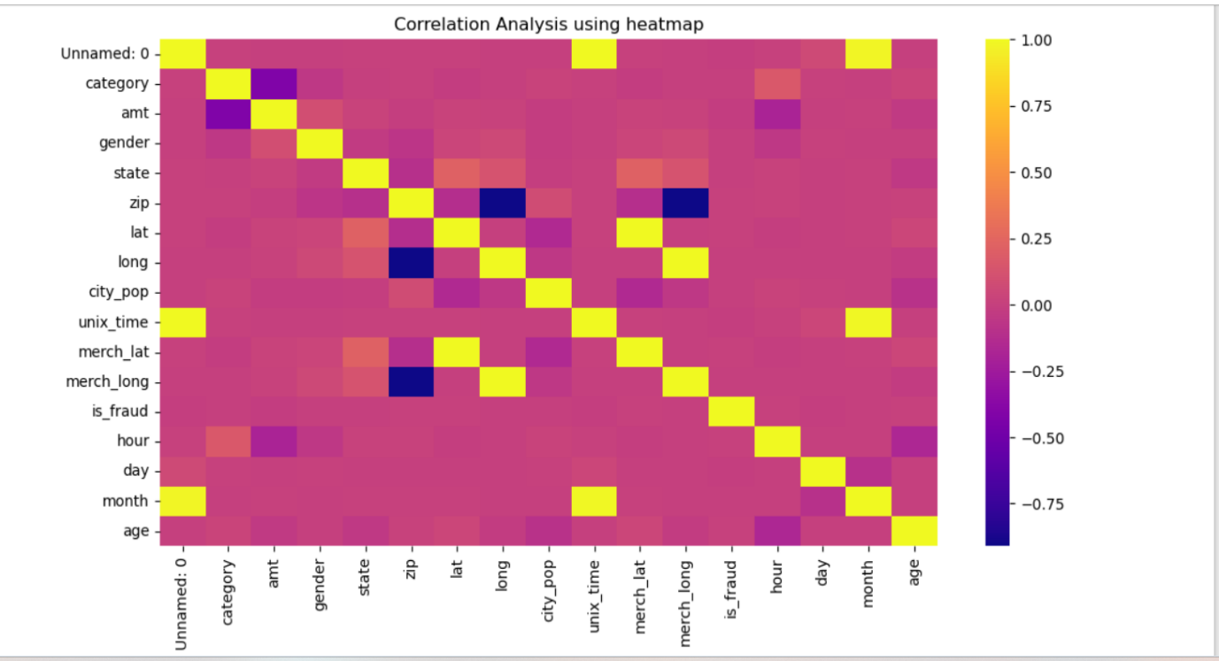
4 . Machine Learning Model Used
4.1 Algorithm Selected
In this project, we selected the Random Forest Classifier to build the fraud detection model. This is a supervised Machine Learning algorithm used for binary classifications.
4.2 Rationale for Choosing Random Forest
- Handles Imbalance data of fraud cases, which are rare, and Random Forest can handle this imbalance pretty well.
- It captures complex patterns between features such as amount, time, and category and fraud, like Non-linear relationships.
- It tells us which features, like transaction amount or time, are most useful for detecting fraud.
- Random Forest isn’t thrown off easily by unusual transactions like outliers.
- No need for scaling because it works with different feature scales like amount, age, etc
4.3 Model Parameters
The Random Forest model was trained using the following parameters
- n_estimators=100--->Number of trees in the forest
- random_state=42 -->Ensures reproducibility of results
These parameters were selected to balance model performance and computation efficiency.
4.4 Model Training: The model was trained using the training dataset, which consisted of 80% of the total data. The remaining 20% was used for testing and evaluation.
4.5 Model Output
The Random Forest predicts whether a transaction is
- 0 --- Legitimate Transaction
- 1 --- Fraudulent Transaction
5. Results and Predictions
To assess performance, the following evaluation metrics were used:
- Accuracy
- Precision
- Recall
- F1-Score
5.1 Accuracy Score
Accuracy measures the overall correctness of the model.
Accuracy = TP+TN/TP+TN+FP+FN
Where: TP ---True Positive (fraud correctly predicted)
TN ---True Negative(Legitimate transactions correctly predicted)
Result: The model achieved an accuracy score of 99%
5.2 Classification-Report
The performance of the Random Forest is summarised using the classification report, which includes precision, recall, F1-score and support for each class.
- Precision indicates the accuracy of fraud predictions
- Recall: out of actual frauds, how many did we catch?
- F1-score: Balances between precision and recall. Good for imbalanced data like fraud detection.
- Support Number of samples in each class(fraud vs non-fraud)
